NORTH-EAST TOUR PACKAGE
GUWAHATI-NAMERI-KAZIRANGA-MAJULI (7D-8N)
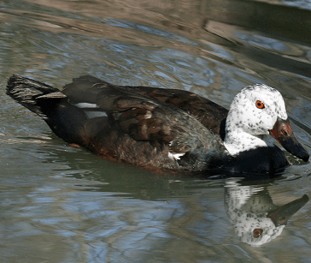
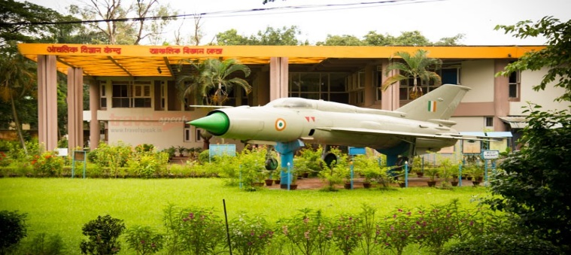
Day 1: Meeting our representative at Guwahati Railway station/Airport after arriving in the morning and drive for the full day city tour- State museum, Science museum, Srimanta Sankardev kalakhetra, Balaji temple, Nabagraha Temple, Dithiol pukhuri, Assam state zoo. Check in hotel and overnight stay.
Day 2: After breakfast transfer to Nameri National Park. Arrive Eco-Camp and check in. After refreshment cross the river Jia Bhorolli by boat and then short walking tour inside the forest accompanied by forest guard. Visitors have to exit the park before sunset. Overnight at Eco-Camp.
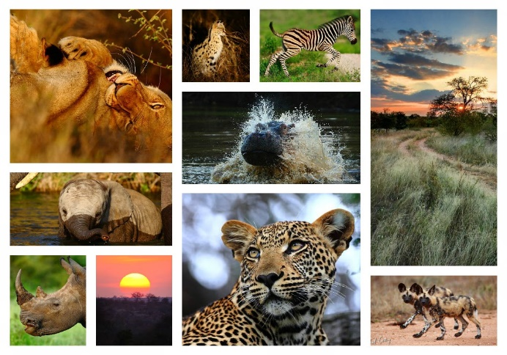
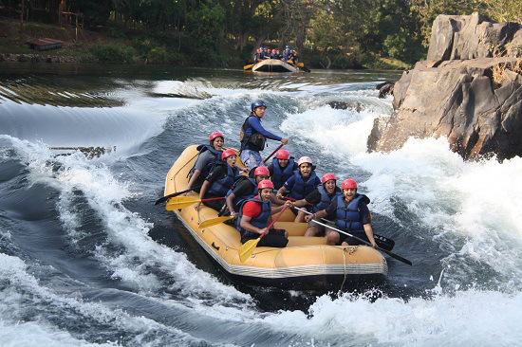
Day 3: After breakfast rafting on Jia Bhorolli river. Possible sighting of Ibisbills while rafting, though sighting of white winged wood ducks need luck and time. Nameri is famous for Birding, rafting and trekking mainly. Overnight stay at Eco-Camp.
Day 4: After breakfast transfer to Kaziranga National Park. Check in hotel and take rest. In the evening enjoy your free time relaxing in the calm and serene atmosphere. Overnight stay at hotel.
Day 5: In the early morning after breakfast enjoy an elephant safari / a jeep safari at Central range (Kohora) / Western range (Bagori) of Kaziranga National Park. Major attractions are One horned rhino ceros, Indian elephant, Swamp deer, Water buffalo, Hoolock gibbon, Royal Bengal tiger, various species of birds and mammals. Overnight Stay at hotel.
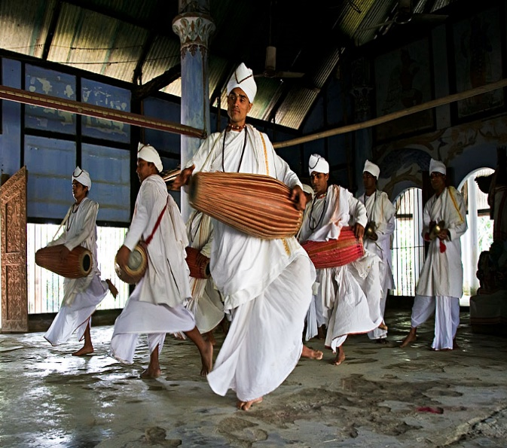
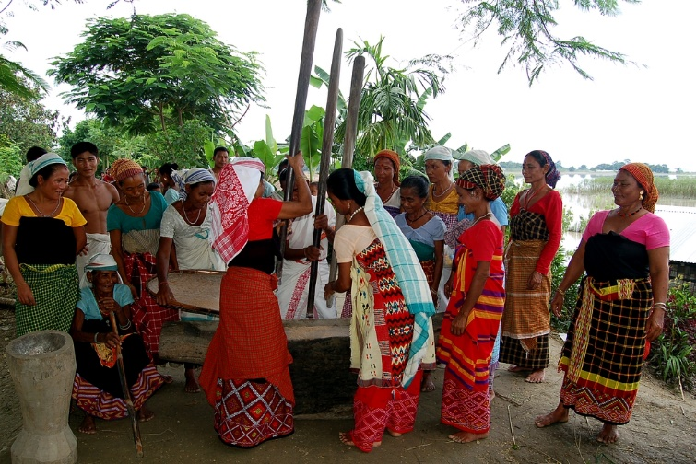
Day 6: Check out hotel and transfer to the Majuli-the biggest river island of the world. Check in hotel. After refreshment visit the Mishing villages to enjoy their ethnic culture. Overnight stay at hotel.
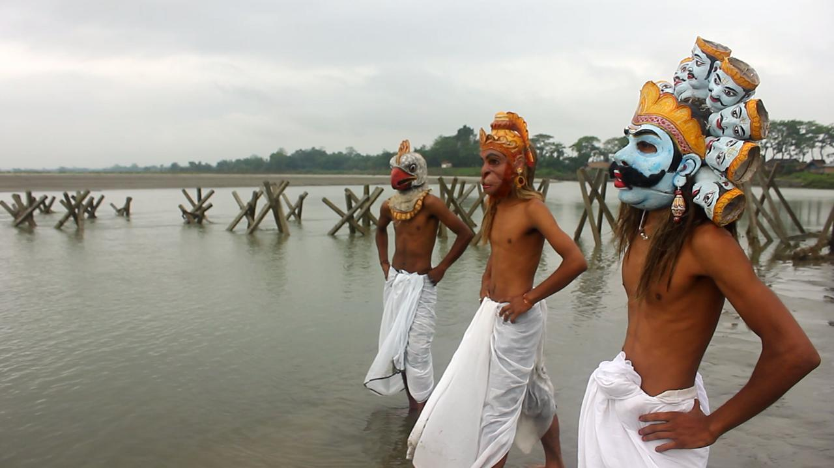
Day 7: After breakfast drive to the full day city tour- Auniati satra, Dakhinpat satra, Kamalabari satra, Bengenati satra, Bhogpur satra, Garamur satra. Vaishnab culture and mask making culture attract tourist mainly. Back to hotel and stay at night.
Day 8: Check out hotel early in the morning and transfer to Guwahati railway station/airport for the final journey.

D

